**Classification Assignment**

**Step 1:** Identify the Problem Statement

The objective is to develop a predictive model to identify whether a patient has Chronic Kidney Disease (CKD) based on several parameters (such as age, blood pressure, blood sugar levels, and other medical indicators).

Type of Problem: Binary Classification

Target variable: class (CKD or not CKD)

Goal: Predict if a patient has CKD (1) or does not have CKD (0).

**Step 2:** Load and Explore the Dataset

**Total Rows:** The number of patient records = 399

**Total Columns:** The features available for prediction (including the target label) = 28

**Step 3:** Pre-processing the Data

**Encoding Categorical Variables**

* Convert categorical data to numerical using **One-Hot Encoding**.

**Feature Scaling**

* Use **StandardScaler** to scale the numerical features.

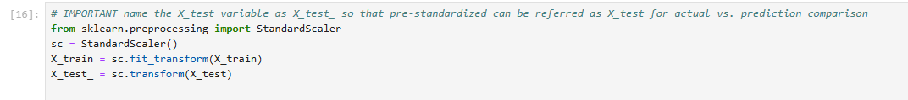

**Step 4:** Split the Dataset and Train Multiple Models

Split the dataset into training and testing sets

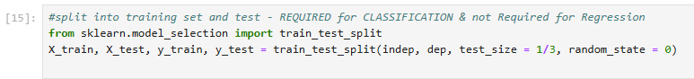

Train Multiple Models

1. Logistic Regression

1. Support Vector Machine (SVM)

1. Decision Tree

1. Random Forest

**Step 5:** Evaluate and Document the Results

**Model Performance Comparison Table**

|  |  |  |  |  |  |
| --- | --- | --- | --- | --- | --- |
| **Model** | **Accuracy** | **Precision** | **Recall** | **F1-Score** | **AUC Score** |
| Logistic Regression | 0.99 | 1.00 | 0.99 | 0.99 | 0.95 |
| SVM | 0.99 | 1.00 | 0.99 | 0.99 | 0.46 |
| Decision Tree | 0.97 | 1.00 | 0.95 | 0.97 | 0.48 |
| Random Forest | 0.98 | 0.99 | 0.99 | 0.99 | 0.99 |

**Step 6:** Select the Best Model / Justification

**Best Model: Random Forest**

It achieves **strong overall metrics**:

* Accuracy: **0.98;** Precision: **0.99;** Recall: **0.99;** F1-Score: **0.99**

It has the **highest AUC score (0.99)**, indicating it has the best ability to distinguish between positive and negative classes.

Even though Logistic Regression has slightly higher accuracy, **Random Forest's superior AUC** makes it the best choice overall, as AUC is a more reliable metric for assessing model performance in classification tasks.

This makes it the **most robust and reliable model** for predicting Chronic Kidney Disease (CKD) in this scenario.